#4 Weekend Email
Elite Club #37 September 2018

Happy weekend to you!
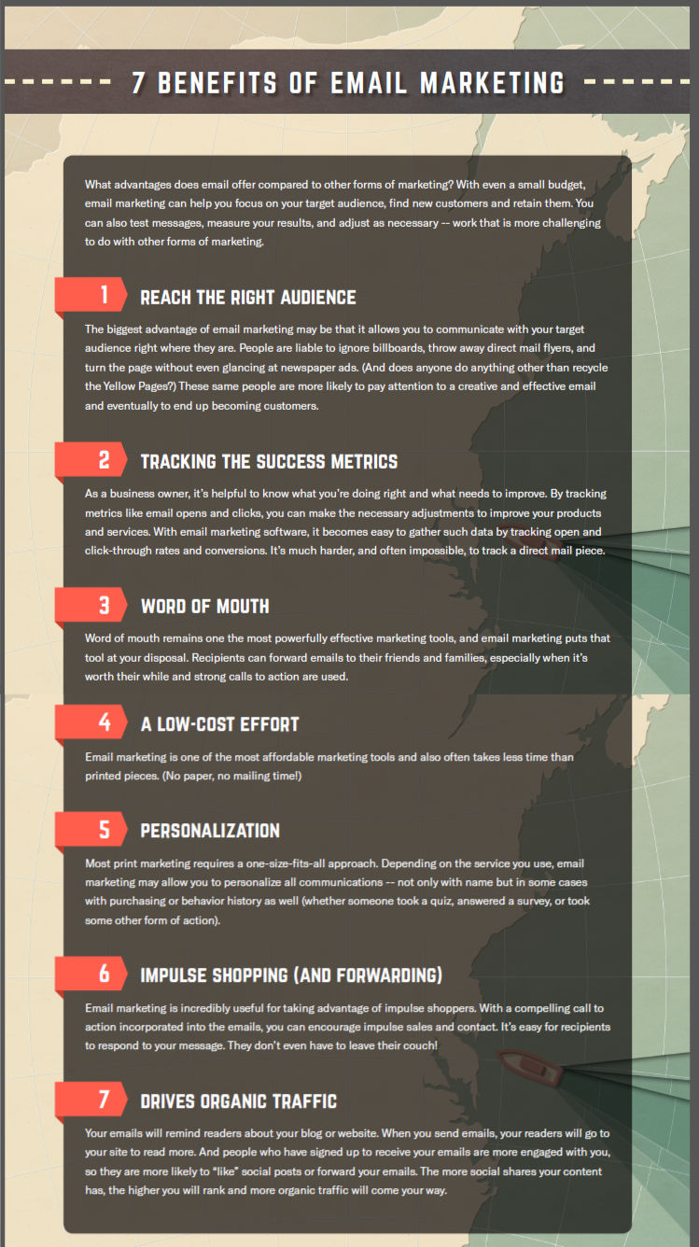
Quick hello. Hope you are having a weekend to remember. Also, “remember” email marketing still remains as one of the best ways to connect with potential clients. Check out the information below about the “7 Benefits of Email Marketing”. I think you will find it very interesting!

