#8 Office Agenda
Elite Club #33 May 2018
1. Title Talk: Many agents have questions on their prelim and we LOVE questions. Please contact my team or myself and I would be more than happy to answer. Plus, with me today I have a flyer called “ALL ABOUT YOUR ESCROW: The Preliminary Title Report”. Please see me after the meeting and I will give you one to check out.
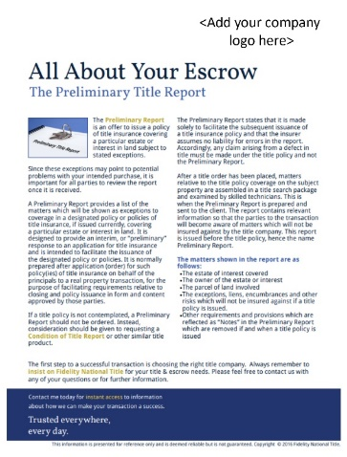

2. Have you checked out Break Through broker lately? It has so many cool features to help you in your business. OPEN HOUSE MARKETING SERIES Establish brand recognition when you use this Open House Marketing Series to invite others to your event. This series includes a matching flyer, postcard and door hanger invite.
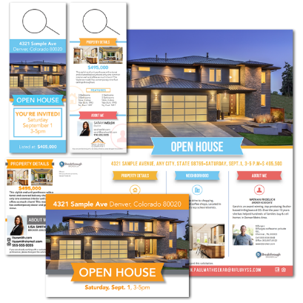

3. Reminders: Tell them about a continuing education classes or a class you have coming up!! <INSERT HERE>

4. Flavor of the month marketing: “Trusted Providers” flyer; “Act Now” Real Estate home price postcard; “Luxury Listing” marketing series.

5. Thank them for their business: My company and I have a message for everyone in the room: You are appreciated, whether you have selected us as your title choice or not, we appreciate what you do for our community to make it a better place. It’s professionals like you that keep our growing and evolving. We love our customers and we look forward to being of service to each and every one of you. Thank you for the opportunity to do so.

7. Quote of the day: “If it’s in your mind, it’s worth taking the risk.”

