***#14 What’s New***

***Elite Club #18 February 2017***

Download IMovie App on your phone or IPAD

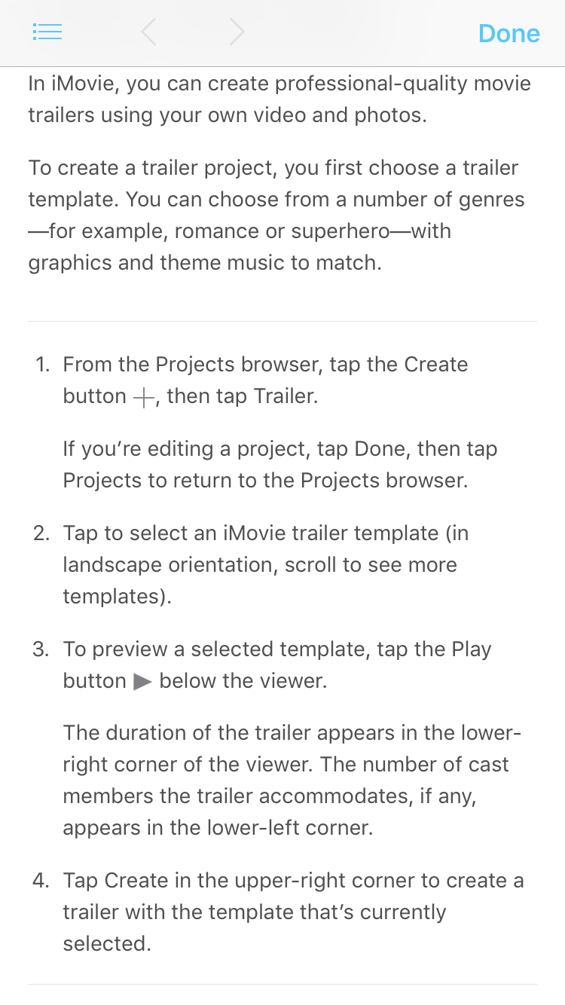

If you want to see one done, email [Lisa.Crown@fnf.com](mailto:Lisa.Crown@fnf.com) & coach will send

you an example!