***#12 ITS Connect Now***

***Elite Club #11 July 2016***

Hello Elite Club Members!

Here is an exclusive sneak peek on a **NEW** feature that has just been added to Connect!  Now you can Drag and Drop documents directly from your computer right into Connect.  Simply login to Connect and navigate to the “Documents” link at the top of the page, from here you can create folders and then drag documents into the appropriate folder(s).  Now you can access and share marketing/promotional materials, coaching materials and more, quickly and easily from your iPad or mobile device!

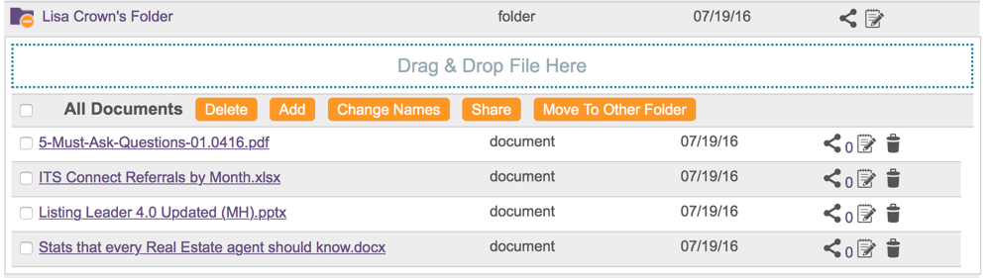

If you would like more information on how you can leverage this **NEW** feature in your market, please reach out to your ITS Business Solutions Representative.